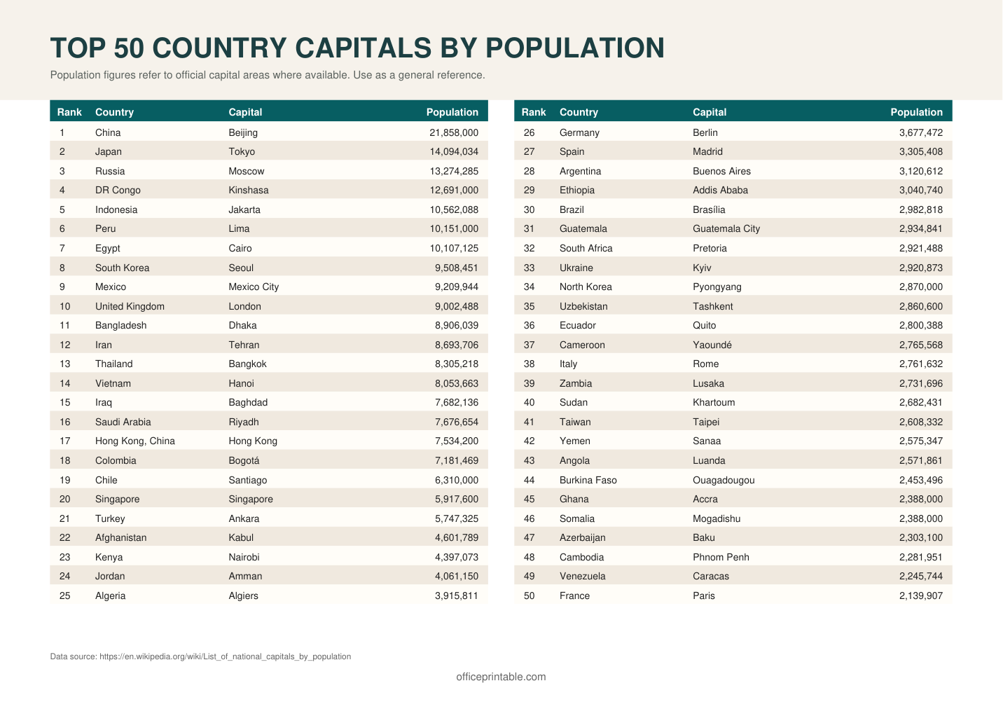

Free World Capitals Reference - Editable Content
The previous page preserves the printable layout. Use this editable section to customize labels, notes, rows, or field text before creating your own final version.
Original text / field | Custom text / notes
TOP 50 COUNTRY CAPITALS BY POPULATION
Population figures refer to official capital areas where available. Use as a general reference.
Rank
Country
Capital
Population
1
China
Beijing
21,858,000
26
Germany
Berlin
3,677,472
2
Japan
Tokyo
14,094,034
27
Spain
Madrid
3,305,408
3
Russia
Moscow
13,274,285
28
Argentina
Buenos Aires
3,120,612
4
DR Congo
Kinshasa
12,691,000
29
Ethiopia
Addis Ababa
3,040,740
5
Indonesia
Jakarta
10,562,088
30
Brazil
Brasília
2,982,818
6
Peru
Lima
10,151,000
31
Guatemala
Guatemala City
2,934,841
7
Egypt
Cairo
10,107,125
32
South Africa
Pretoria
2,921,488
8
South Korea
Seoul
9,508,451
33
Ukraine
Kyiv
2,920,873
9
Mexico
Mexico City
9,209,944
34
North Korea
Pyongyang
2,870,000
10
United Kingdom
London
9,002,488
35
Uzbekistan
Tashkent
2,860,600
11
Bangladesh
Dhaka
8,906,039
36
Ecuador
Quito
2,800,388
12
Iran
Tehran
8,693,706
37
Cameroon
Yaoundé
2,765,568
13
Thailand
Bangkok
8,305,218
38
Italy
Rome
2,761,632
14
Vietnam
Hanoi
8,053,663
39
Zambia
Lusaka
2,731,696
15
Iraq
Baghdad
7,682,136
40
Sudan
Khartoum
2,682,431
16
Saudi Arabia
Riyadh
7,676,654
41
Taiwan
Taipei
2,608,332
17
Hong Kong, China
Hong Kong
7,534,200
42
Yemen
Sanaa
2,575,347
18
Colombia
Bogotá
7,181,469
43
Angola
Luanda
2,571,861
19
Chile
Santiago
6,310,000
44
Burkina Faso
Ouagadougou
2,453,496
20
Singapore
5,917,600
45
Ghana
Accra
2,388,000
21
Turkey
Ankara
5,747,325
46
Somalia
Mogadishu
22
Afghanistan
Kabul
4,601,789
47
Azerbaijan
Baku
2,303,100
23
Kenya
Nairobi
4,397,073
48
Cambodia
Phnom Penh
2,281,951
24
Jordan
Amman
4,061,150
49
Venezuela
Caracas
2,245,744
25
Algeria
Algiers
3,915,811
50
France
Paris
2,139,907
Data source: https://en.wikipedia.org/wiki/List_of_national_capitals_by_population
officeprintable.com

