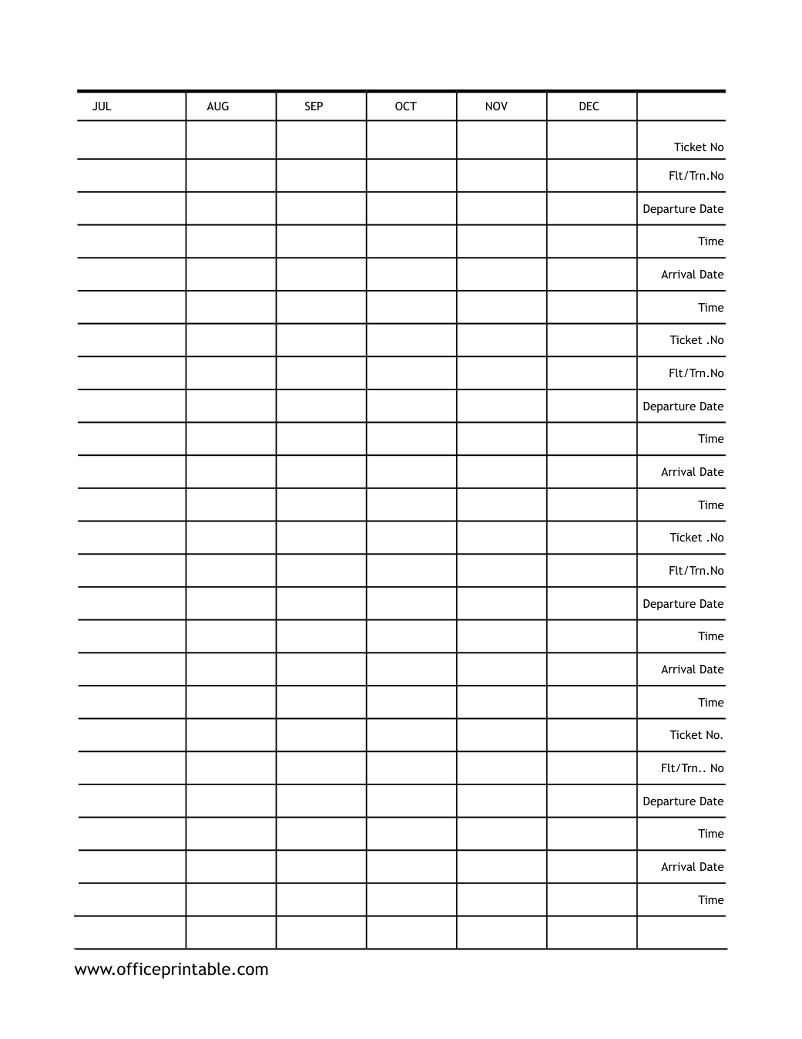

Free Travel Plan Printable: Jul-Dec - Editable Content
The previous page preserves the printable layout. Use this editable section to customize labels, notes, rows, or field text before creating your own final version.
Original text / field | Custom text / notes
JUL
AUG
SEP
OCT
NOV
DEC
Ticket No
Flt/Trn.No
Departure Date
Time
Arrival Date
Ticket .No
Ticket No.
Flt/Trn.. No
www.officeprintable.com
officeprintable.com

