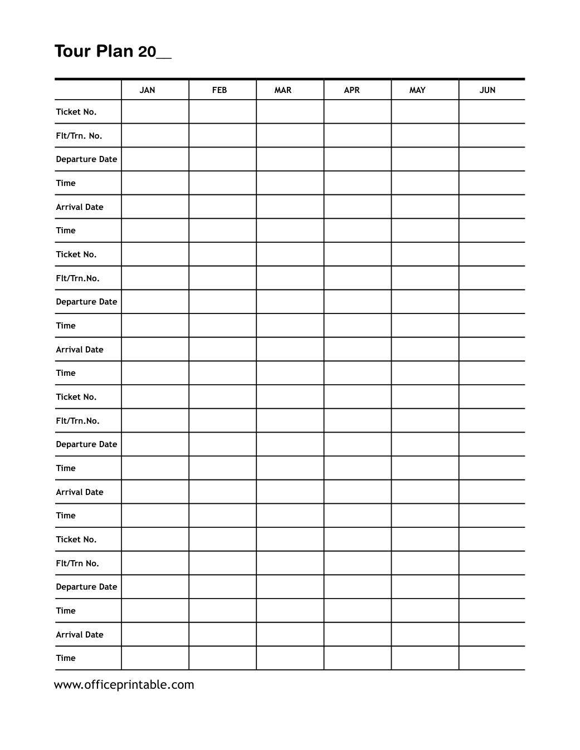

Free Travel Plan Printable: Jan-Jun - Editable Content
The previous page preserves the printable layout. Use this editable section to customize labels, notes, rows, or field text before creating your own final version.
Original text / field | Custom text / notes
Tour Plan 20__
JAN
FEB
MAR
APR
MAY
JUN
Ticket No.
Flt/Trn. No.
Departure Date
Time
Arrival Date
Flt/Trn.No.
Flt/Trn No.
www.officeprintable.com
officeprintable.com

