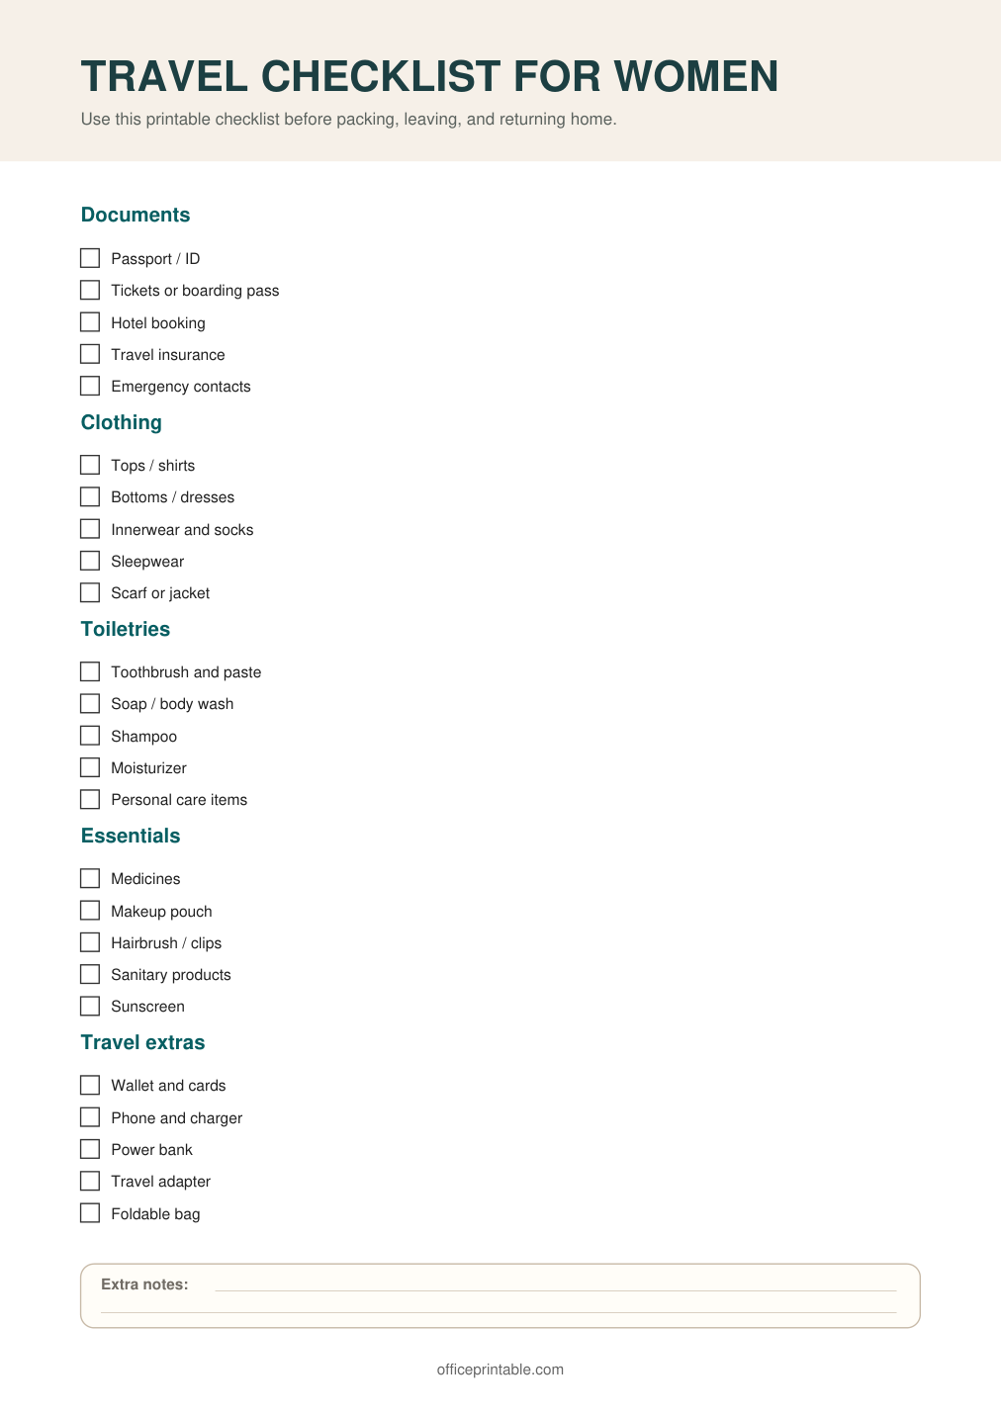

Free Travel Checklist for Women - Editable Content
The previous page preserves the printable layout. Use this editable section to customize labels, notes, rows, or field text before creating your own final version.
Original text / field | Custom text / notes
TRAVEL CHECKLIST FOR WOMEN
Use this printable checklist before packing, leaving, and returning home.
Documents
Passport / ID
Tickets or boarding pass
Hotel booking
Travel insurance
Emergency contacts
Clothing
Tops / shirts
Bottoms / dresses
Innerwear and socks
Sleepwear
Scarf or jacket
Toiletries
Toothbrush and paste
Soap / body wash
Shampoo
Moisturizer
Personal care items
Essentials
Medicines
Makeup pouch
Hairbrush / clips
Sanitary products
Sunscreen
Travel extras
Wallet and cards
Phone and charger
Power bank
Travel adapter
Foldable bag
Extra notes:
officeprintable.com

