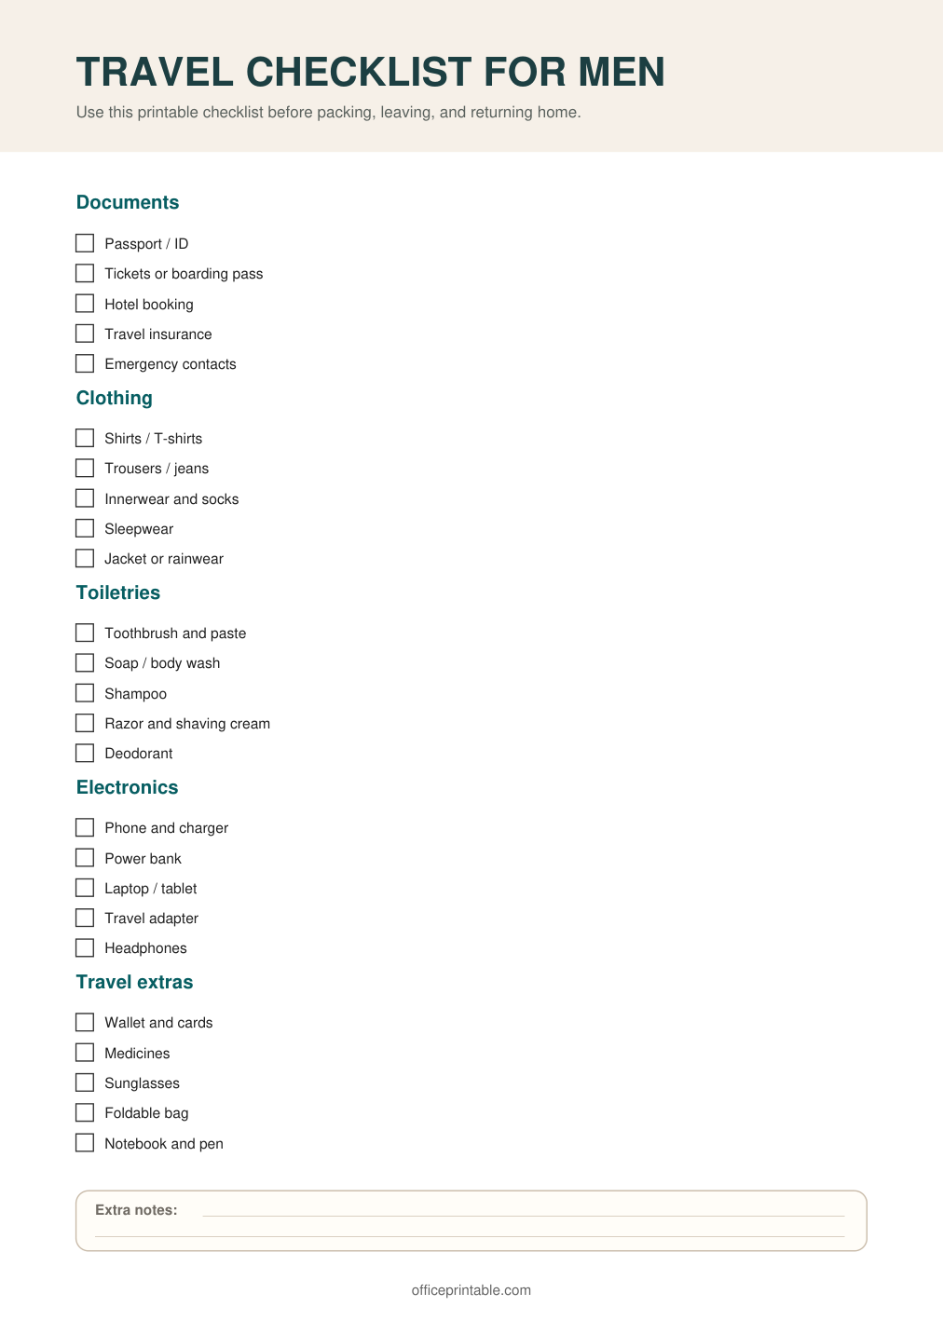

Free Travel Checklist for Men - Editable Content
The previous page preserves the printable layout. Use this editable section to customize labels, notes, rows, or field text before creating your own final version.
Original text / field | Custom text / notes
TRAVEL CHECKLIST FOR MEN
Use this printable checklist before packing, leaving, and returning home.
Documents
Passport / ID
Tickets or boarding pass
Hotel booking
Travel insurance
Emergency contacts
Clothing
Shirts / T-shirts
Trousers / jeans
Innerwear and socks
Sleepwear
Jacket or rainwear
Toiletries
Toothbrush and paste
Soap / body wash
Shampoo
Razor and shaving cream
Deodorant
Electronics
Phone and charger
Power bank
Laptop / tablet
Travel adapter
Headphones
Travel extras
Wallet and cards
Medicines
Sunglasses
Foldable bag
Notebook and pen
Extra notes:
officeprintable.com

