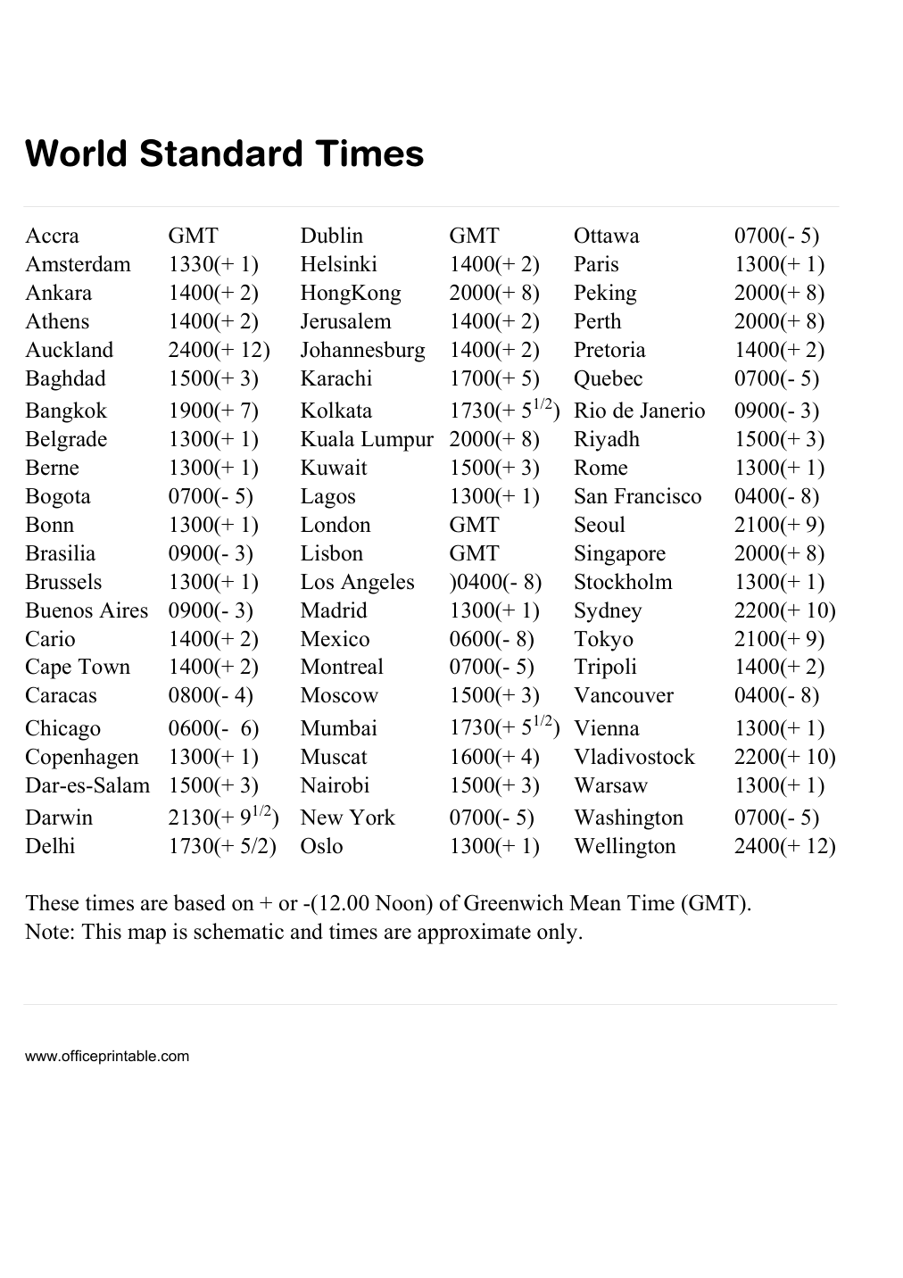

Free Top Cities Time With Respect to GMT - Editable Content
The previous page preserves the printable layout. Use this editable section to customize labels, notes, rows, or field text before creating your own final version.
Original text / field | Custom text / notes
World Standard Times
Accra
GMT
Dublin
Ottawa
0700(- 5)
Amsterdam
1330(+ 1)
Helsinki
1400(+ 2)
Paris
1300(+ 1)
Ankara
2000(+ 8)
Peking
Athens
Jerusalem
Perth
Auckland
2400(+ 12)
Johannesburg
Pretoria
Baghdad
1500(+ 3)
Karachi
1700(+ 5)
Quebec
Bangkok
1900(+ 7)
0900(- 3)
Belgrade
Riyadh
Kuwait
Rome
Bogota
Lagos
San Francisco
0400(- 8)
Bonn
London
Seoul
2100(+ 9)
Brasilia
Lisbon
Singapore
Brussels
Los Angeles
)0400(- 8)
Stockholm
Madrid
Sydney
2200(+ 10)
Mexico
0600(- 8)
Tokyo
Cape Town
Montreal
Tripoli
Caracas
0800(- 4)
Moscow
Vancouver
Chicago
0600(- 6)
Mumbai
Vienna
Copenhagen
Muscat
1600(+ 4)
Nairobi
Warsaw
Darwin
New York
Washington
Delhi
1730(+ 5/2)
Oslo
Wellington
HongKong
Kolkata
1730(+ 51/2) Rio de Janerio
Kuala Lumpur
Berne
Buenos Aires
Cario
1730(+ 51/2)
Vladivostock
Dar-es-Salam
2130(+ 91/2)
These times are based on + or -(12.00 Noon) of Greenwich Mean Time (GMT).
Note: This map is schematic and times are approximate only.
www.officeprintable.com
officeprintable.com

