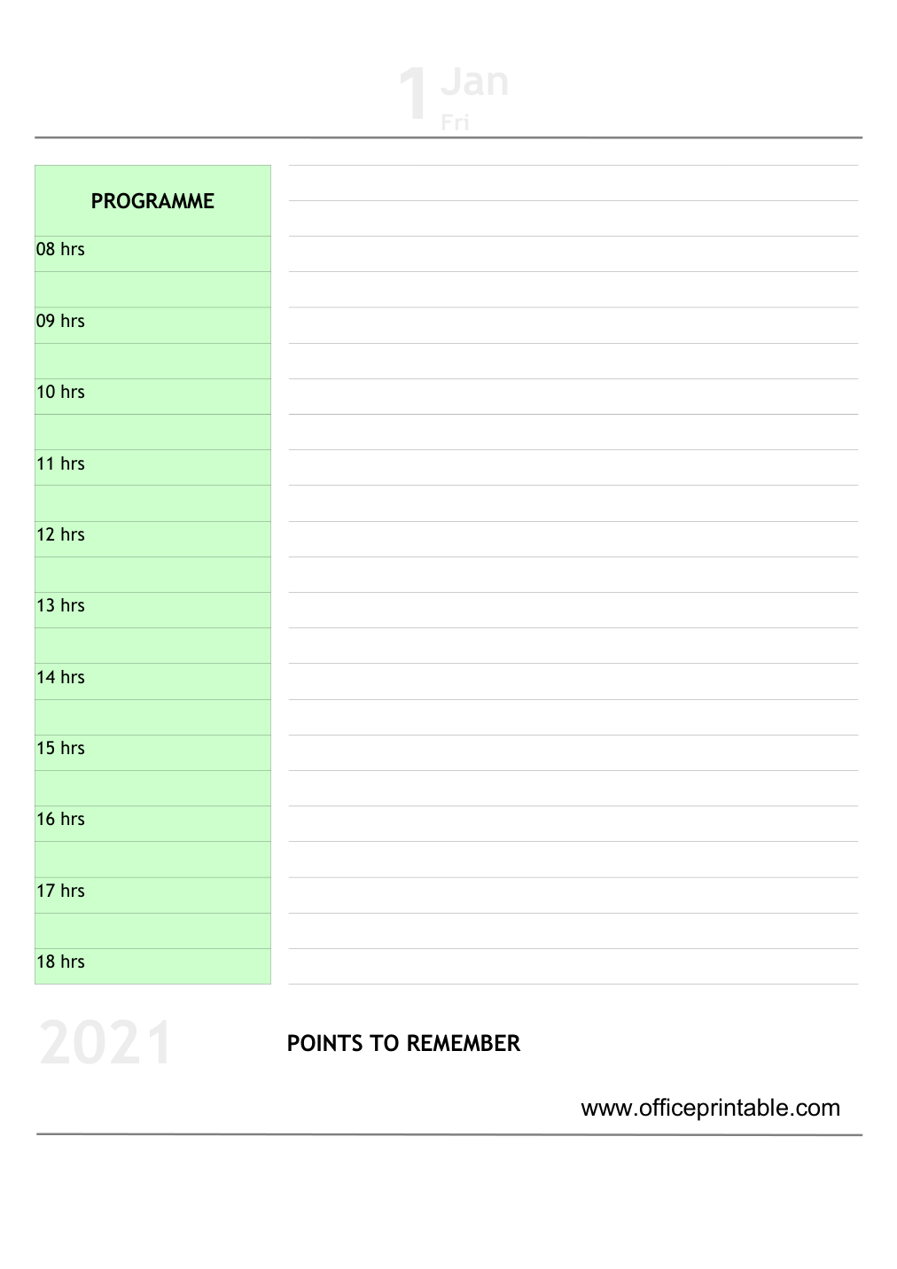

Free Daily To-Do List - Editable Content
The previous page preserves the printable layout. Use this editable section to customize labels, notes, rows, or field text before creating your own final version.
Original text / field | Custom text / notes
1Jan
Fri
PROGRAMME
08 hrs
09 hrs
10 hrs
11 hrs
12 hrs
13 hrs
14 hrs
15 hrs
16 hrs
17 hrs
18 hrs
2021 POINTS TO REMEMBER
www.officeprintable.com
officeprintable.com

