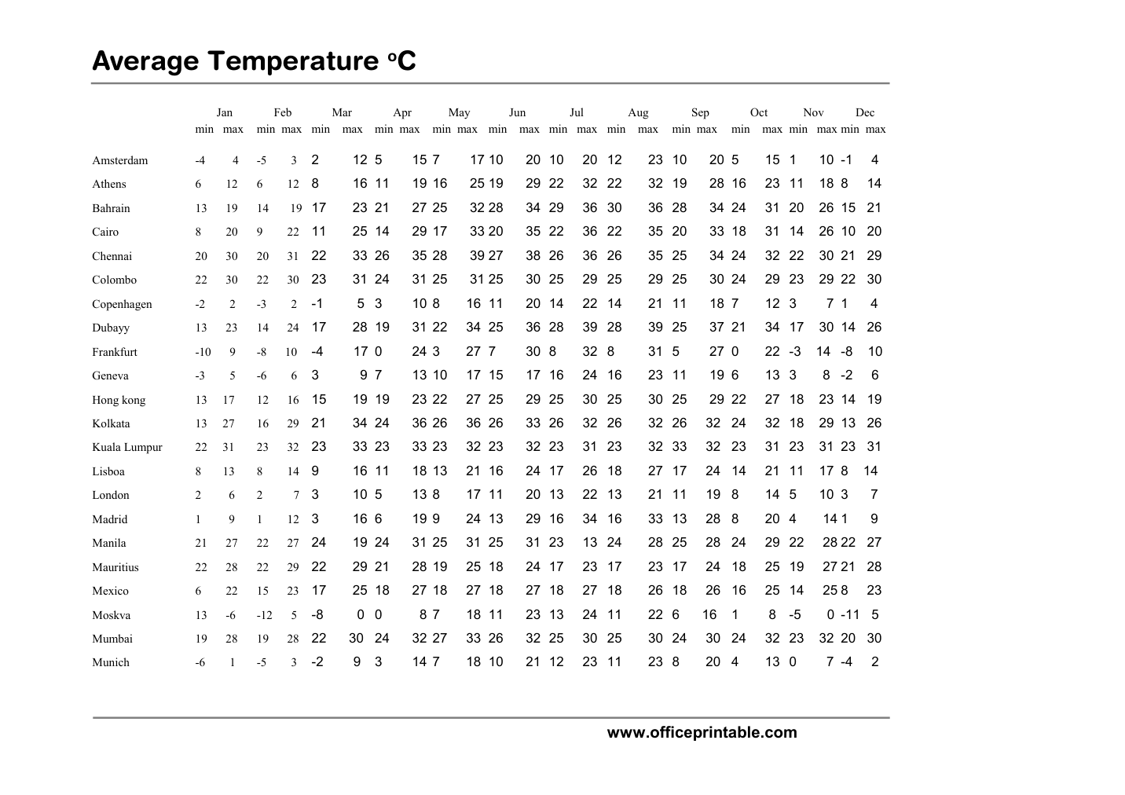

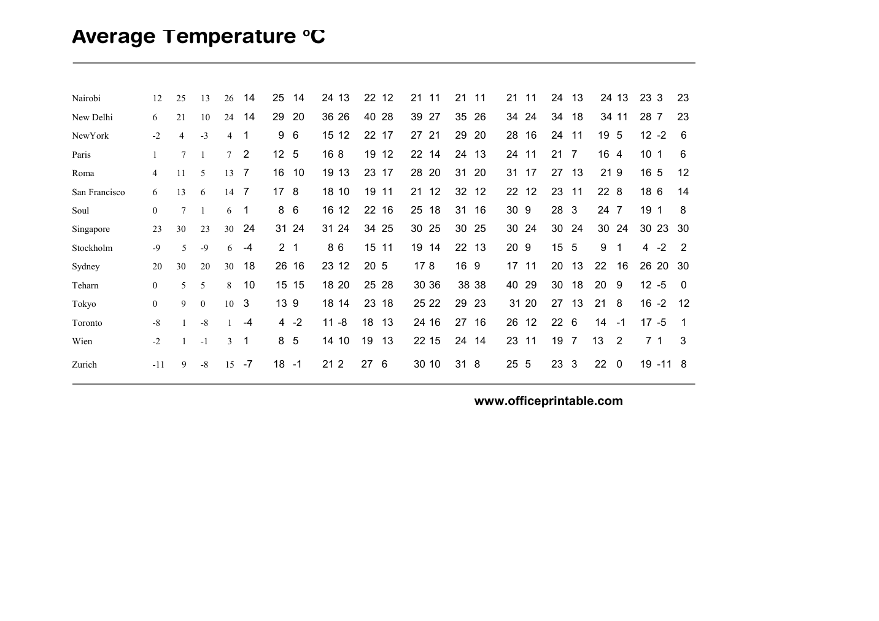

Free Temperature Reference Chart - Editable Content
The previous page preserves the printable layout. Use this editable section to customize labels, notes, rows, or field text before creating your own final version.
Original text / field | Custom text / notes
Average Temperature oC
Jan
Feb
Mar
Apr
May
Jun
Jul
Aug
Sep
Oct
Nov
Dec
min max
min max min max
min max min max min max
Amsterdam
-4 4
-5 3
2 12 5 15 7 17 10 20 10 20 12 23 10 20 5 15 1 10 -1 4
Athens
6 12
8 16 11 19 16 25 19 29 22 32 22 32 19 28 16 23 11 18 8 14
Bahrain
13 19
14 19 17 23 21 27 25 32 28 34 29 36 30 36 28 34 24 31 20 26 15 21
Cairo
8 20
9 22
11 25 14 29 17 33 20 35 22 36 22 35 20 33 18 31 14 26 10 20
Chennai
20 30
20 31
22 33 26 35 28 39 27 38 26 36 26 35 25 34 24 32 22 30 21 29
Colombo
22 30
22 30 23 31 24 31 25 31 25 30 25 29 25 29 25 30 24 29 23 29 22 30
Copenhagen
-2 2
-3 2
-1 5 3 10 8 16 11 20 14 22 14 21 11 18 7 12 3 7 1 4
13 23
14 24
17 28 19 31 22 34 25 36 28 39 28 39 25 37 21 34 17 30 14 26
Dubayy
Frankfurt
-10 9
-8 10
-4 17 0 24 3 27 7 30 8 32 8 31 5 27 0 22 -3 14 -8 10
Geneva
-3 5
-6 6
3 9 7 13 10 17 15 17 16 24 16 23 11 19 6 13 3 8
-2 6
13 17
12 16
15 19 19 23 22 27 25 29 25 30 25 30 25 29 22 27 18 23 14 19
Hong kong
13 27
16 29
21 34 24 36 26 36 26 33 26 32 26 32 26 32
24 32 18 29 13 26
Kolkata
22 31
23 32
23 33 23 33 23 32 23 32 23 31 23 32 33 32
23 31 23 31 23 31
Kuala Lumpur
8 13
8 14
9 16 11 18 13 21 16 24 17 26 18 27 17 24
14 21 11 17 8 14
Lisboa
London
2 6
2 7
3 10 5 13 8 17 11 20 13 22 13 21 11 19
8 14 5 10 3 7
Madrid
1 9
1 12
3 16 6 19 9 24 13 29 16 34 16 33 13 28
8 20 4 14 1 9
Manila
21 27
22 27
24 19 24 31 25 31 25 31 23 13 24 28 25 28
24 29 22 28 22 27
Mauritius
22 28
22 29
22 29 21 28 19 25 18 24 17 23 17 23 17 24
18 25 19 27 21 28
Mexico
6 22
15 23
17 25 18 27 18 27 18 27 18 27 18 26 18 26
16 25 14 25 8 23
13 -6
-12 5
-8 0 0 8 7 18 11 23 13 24 11 22 6 16
1 8
-5 0 -11 5
Moskva
Mumbai
19 28
24 32 27 33 26 32 25 30 25 30 24 30
24 32 23 32 20 30
Munich
-6 1
-2 9
3 14 7 18 10 21 12 23 11 23 8 20
4 13 0 7 -4 2
www.officeprintable.com
Nairobi
12 25
13 26
14 25 14 24 13 22 12 21 11 21 11 21 11 24
13 24 13 23 3 23
New Delhi
6 21
10 24
14 29
20 36 26 40 28 39 27 35 26 34 24 34
18 34 11 28 7 23
-2 4
-3 4
6 15 12 22 17 27 21 29 20 28 16 24
11 19 5 12 -2 6
NewYork
Paris
1 7
2 12
5 16 8 19 12 22 14 24 13 24 11 21
7 16 4 10 1 6
4 11
5 13
7 16
10 19 13 23 17 28 20 31 20 31 17 27
13 21 9 16 5 12
Roma
San Francisco
6 13
6 14
7 17
8 18 10 19 11 21 12 32 12 22 12 23
11 22 8 18 6 14
Soul
0 7
1 6
6 16 12 22 16 25 18 31 16 30 9 28
3 24 7 19 1 8
Singapore
23 30
24 31 24 31 24 34 25 30 25 30 25 30 24 30
24 30 24 30 23 30
Stockholm
-9 5
-9 6
-4 2 1 8 6 15 11 19 14 22 13 20 9 15
5 9
1 4
Sydney
18 26 16 23 12 20 5 17 8 16 9 17 11 20
13 22
16 26 20 30
0 5
5 8
10 15 15 18 20 25 28 30 36 38 38 40 29 30
18 20
9 12 -5 0
Teharn
Tokyo
0 9
0 10
3 13 9 18 14 23 18 25 22 29 23 31 20 27
13 21
8 16 -2 12
Toronto
-8 1
-4 4 -2 11 -8 18
13 24 16 27 16 26 12 22
-1 17 -5 1
-2 1
-1 3
5 14 10 19
13 22 15 24 14 23 11 19
7 13
2 7 1 3
Wien
Zurich
-11 9
-8 15
-7 18 -1 21 2 27
6 30 10 31 8 25 5 23
3 22
0 19 -11 8
officeprintable.com

