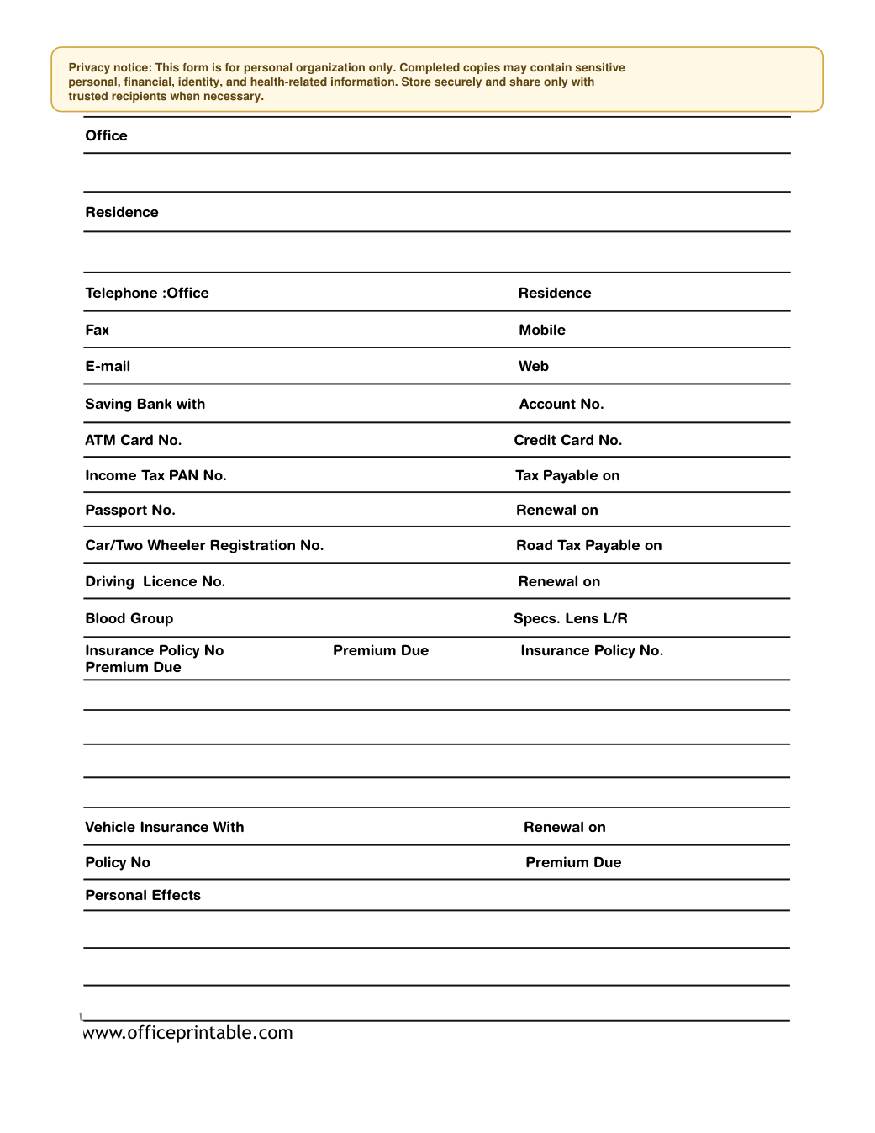

Free Personal Data Request Form - Editable Content
The previous page preserves the printable layout. Use this editable section to customize labels, notes, rows, or field text before creating your own final version.
Original text / field | Custom text / notes
Personal Data
Privacy notice: This form is for personal organization only. Completed copies may contain sensitive
personal, financial, identity, and health-related information. Store securely and share only with
trusted recipients when necessary.
NAME
Office
Residence
Telephone :Office Residence
Fax Mobile
E-mail Web
Saving Bank with Account No.
ATM Card No. Credit Card No.
Income Tax PAN No. Tax Payable on
Passport No. Renewal on
Car/Two Wheeler Registration No. Road Tax Payable on
Driving Licence No. Renewal on
Blood Group Specs. Lens L/R
Insurance Policy No Premium Due Insurance Policy No.
Premium Due
Vehicle Insurance With Renewal on
Policy No Premium Due
Personal Effects
www.officeprintable.com
officeprintable.com

