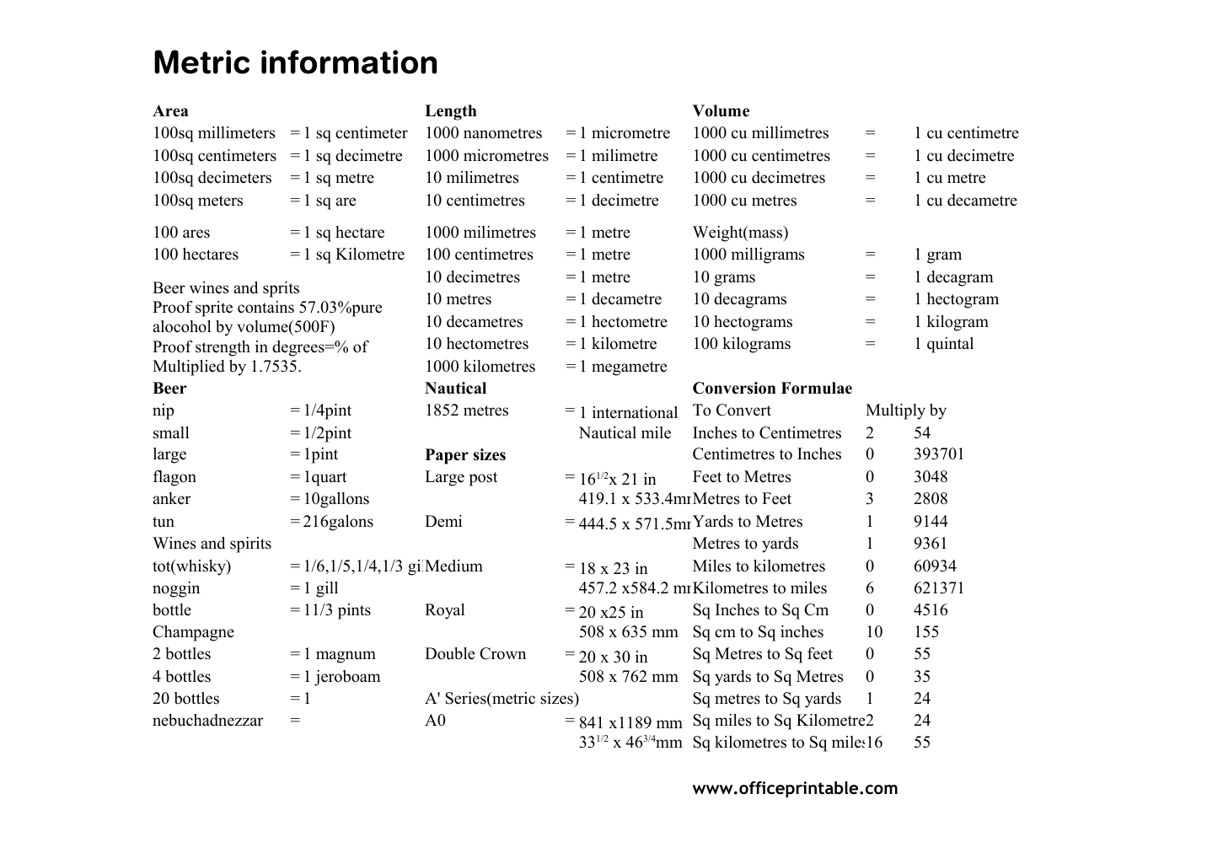

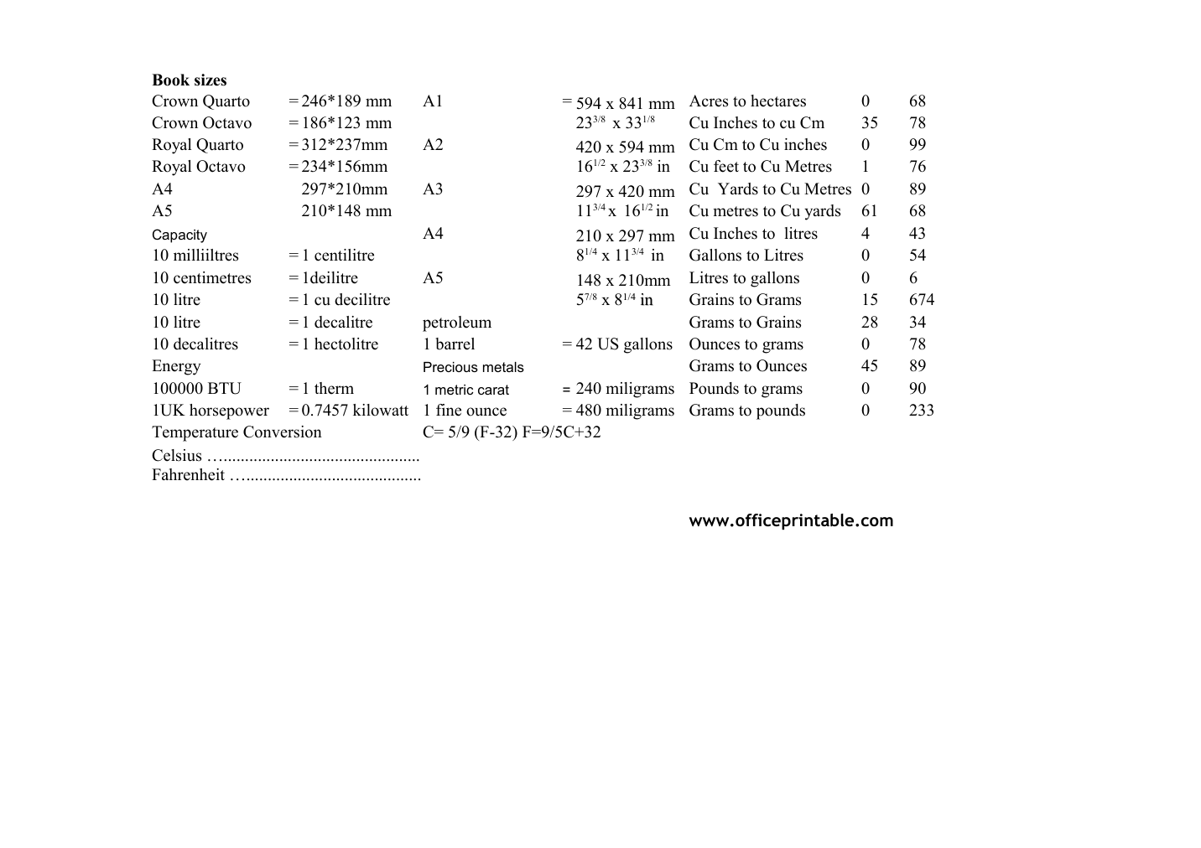

Free Metric Information Chart - Editable Content
The previous page preserves the printable layout. Use this editable section to customize labels, notes, rows, or field text before creating your own final version.
Original text / field | Custom text / notes
Metric information
Area
Length
Volume
100sq millimeters = 1 sq centimeter
=
100sq centimeters =
100sq decimeters =
100sq meters = 1 sq are
1000 nanometres
1 micrometre
1000 cu millimetres
1 cu centimetre
1 sq decimetre
1000 micrometres
1 milimetre
1000 cu centimetres
1 cu decimetre
1 sq metre
10 milimetres
1 centimetre
1000 cu decimetres
1 cu metre
10 centimetres
1 decimetre
1000 cu metres
1 cu decametre
100 ares = 1 sq hectare
Weight(mass)
100 hectares =
1000 milligrams
1 gram
10 grams
1 hectogram
10 hectograms
1 kilogram
100 kilograms
Beer
Nautical
nip
= 1/4pint
To Convert
Multiply by
small
= 1/2pint
2
54
large
= 1pint
Paper sizes
0
393701
flagon
= 1quart
Large post
3048
= 10gallons
3
2808
tun
= 216galons
1
9144
Wines and spirits
9361
= 1/6,1/5,1/4,1/3 gilMedium
60934
noggin
= 1 gill
6
621371
bottle
= 11/3 pints
Royal
Sq Inches to Sq Cm
4516
Champagne
Sq cm to Sq inches
10
155
2 bottles
= 1 magnum
Double Crown
55
4 bottles
= 1 jeroboam
35
20 bottles
= 1
A' Series(metric sizes)
24
A0
16
1000 milimetres
1 metre
1 sq Kilometre
100 centimetres
10 decimetres
1 decagram
10 metres
1 decametre
10 decagrams
10 decametres
1 hectometre
10 hectometres
1 kilometre
1 quintal
1000 kilometres
1 megametre
Beer wines and sprits
Proof sprite contains 57.03%pure
alocohol by volume(500F)
Proof strength in degrees=% of
Multiplied by 1.7535.
Conversion Formulae
1852 metres
1 international
Nautical mile
Inches to Centimetres
Centimetres to Inches
161/2x 21 in
419.1 x 533.4mm
Feet to Metres
anker
Metres to Feet
Demi
7
444.5 x 571.5mmYards to Metres
Metres to yards
tot(whisky)
18 x 23 in
457.2 x584.2 mm
Miles to kilometres
Kilometres to miles
20 x25 in
508 x 635 mm
20 x 30 in
508 x 762 mm
Sq Metres to Sq feet
Sq yards to Sq Metres
Sq metres to Sq yards
nebuchadnezzar
841 x1189 mm
331/2 x 463/4mm
Sq miles to Sq Kilometre
Sq kilometres to Sq miles
www.officeprintable.com
Book sizes
Crown Quarto
= 246*189 mm
A1
Acres to hectares
68
Crown Octavo
= 186*123 mm
Cu Inches to cu Cm
78
Royal Quarto
= 312*237mm
A2
Cu Cm to Cu inches
99
Royal Octavo
= 234*156mm
76
A4
297*210mm
A3
89
A5
210*148 mm
61
594 x 841 mm
233/8 x 331/8
420 x 594 mm
161/2 x 233/8 in
Cu feet to Cu Metres
297 x 420 mm
113/4 x 161/2 in
Cu Yards to Cu Metres
Cu metres to Cu yards
210 x 297 mm
81/4 x 113/4 in
Cu Inches to litres
10 milliiltres
1 centilitre
Gallons to Litres
148 x 210mm
57/8 x 81/4
1/4 in
in
Capacity
4
43
= 1deilitre
Grains to Grams
15
674
petroleum
Grams to Grains
28
34
1 barrel
= 42 US gallons
Ounces to grams
Energy
Precious metals
Grams to Ounces
45
100000 BTU
= 1 therm
1 metric carat
Pounds to grams
90
1UK horsepower
= 0.7457 kilowatt
1 fine ounce
Grams to pounds
233
Temperature Conversion
C= 5/9 (F-32) F=9/5C+32
Litres to gallons
10 litre
1 cu decilitre
1 decalitre
10 decalitres
1 hectolitre
240 miligrams
480 miligrams
Celsius …..............................................
Fahrenheit ….........................................
officeprintable.com

