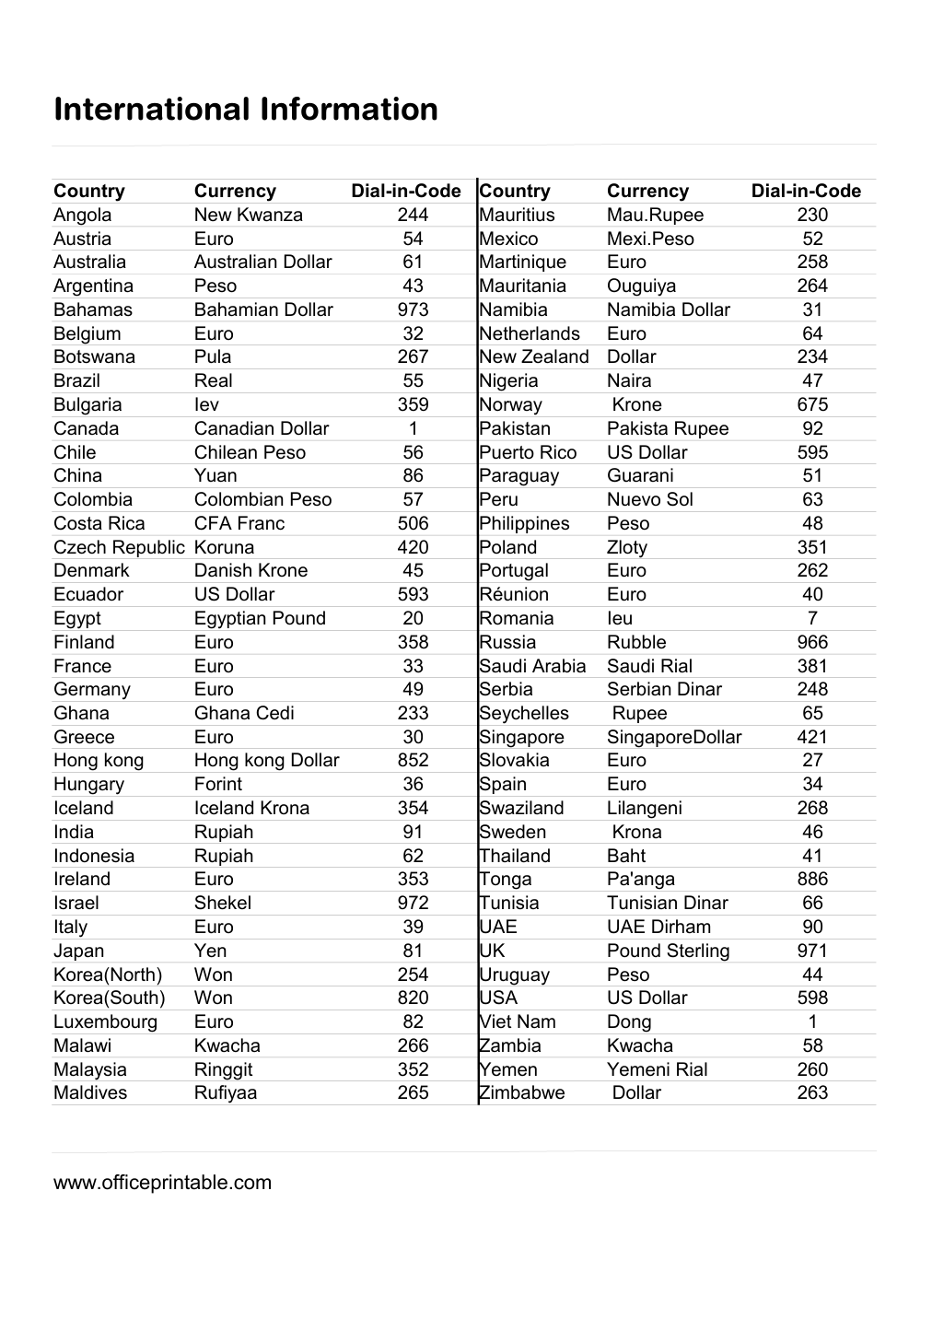

Free International Currency and Calling Codes - Editable Content
The previous page preserves the printable layout. Use this editable section to customize labels, notes, rows, or field text before creating your own final version.
Original text / field | Custom text / notes
International Information
Country
Currency
Dial-in-Code
Angola
244
Mauritius
230
Austria
Euro
54
Mexico
52
Australia
Australian Dollar
61
Martinique
258
Argentina
Peso
43
Mauritania
264
Bahamas
Bahamian Dollar
973
Namibia
Namibia Dollar
31
Belgium
32
Netherlands
64
Botswana
267
New Zealand
Dollar
234
Brazil
Real
55
Nigeria
47
Bulgaria
359
Norway
Krone
675
Canada
Canadian Dollar
1
Pakistan
92
Chile
Chilean Peso
56
Puerto Rico
US Dollar
595
China
Yuan
86
Paraguay
Guarani
51
Colombia
Colombian Peso
57
Peru
63
CFA Franc
506
Philippines
48
Czech Republic
420
Poland
Zloty
351
Denmark
Danish Krone
45
Portugal
262
Ecuador
593
40
Egypt
Egyptian Pound
20
Romania
7
Finland
358
Russia
Rubble
966
France
33
Saudi Arabia
Saudi Rial
381
Germany
49
Serbia
Serbian Dinar
248
Ghana
233
Seychelles
Rupee
65
Greece
30
Singapore
421
852
Slovakia
27
Hungary
36
Spain
34
Iceland
Iceland Krona
354
Swaziland
268
India
Rupiah
91
Sweden
Krona
46
Indonesia
62
Thailand
Baht
41
Ireland
353
Tonga
886
Israel
Shekel
972
Tunisia
Tunisian Dinar
66
Italy
39
UAE
90
Japan
Yen
81
UK
Pound Sterling
971
Korea(North)
Won
254
Uruguay
44
Korea(South)
820
USA
598
Luxembourg
82
Dong
Malawi
266
Zambia
58
Malaysia
Ringgit
352
Yemen
Yemeni Rial
260
Maldives
265
Zimbabwe
263
New Kwanza
Mau.Rupee
Mexi.Peso
Ouguiya
Pula
Naira
Iev
Pakista Rupee
Nuevo Sol
Costa Rica
Koruna
Réunion
Ieu
Ghana Cedi
SingaporeDollar
Hong kong
Hong kong Dollar
Forint
Lilangeni
Pa'anga
UAE Dirham
Viet Nam
Kwacha
Rufiyaa
www.officeprintable.com
officeprintable.com

