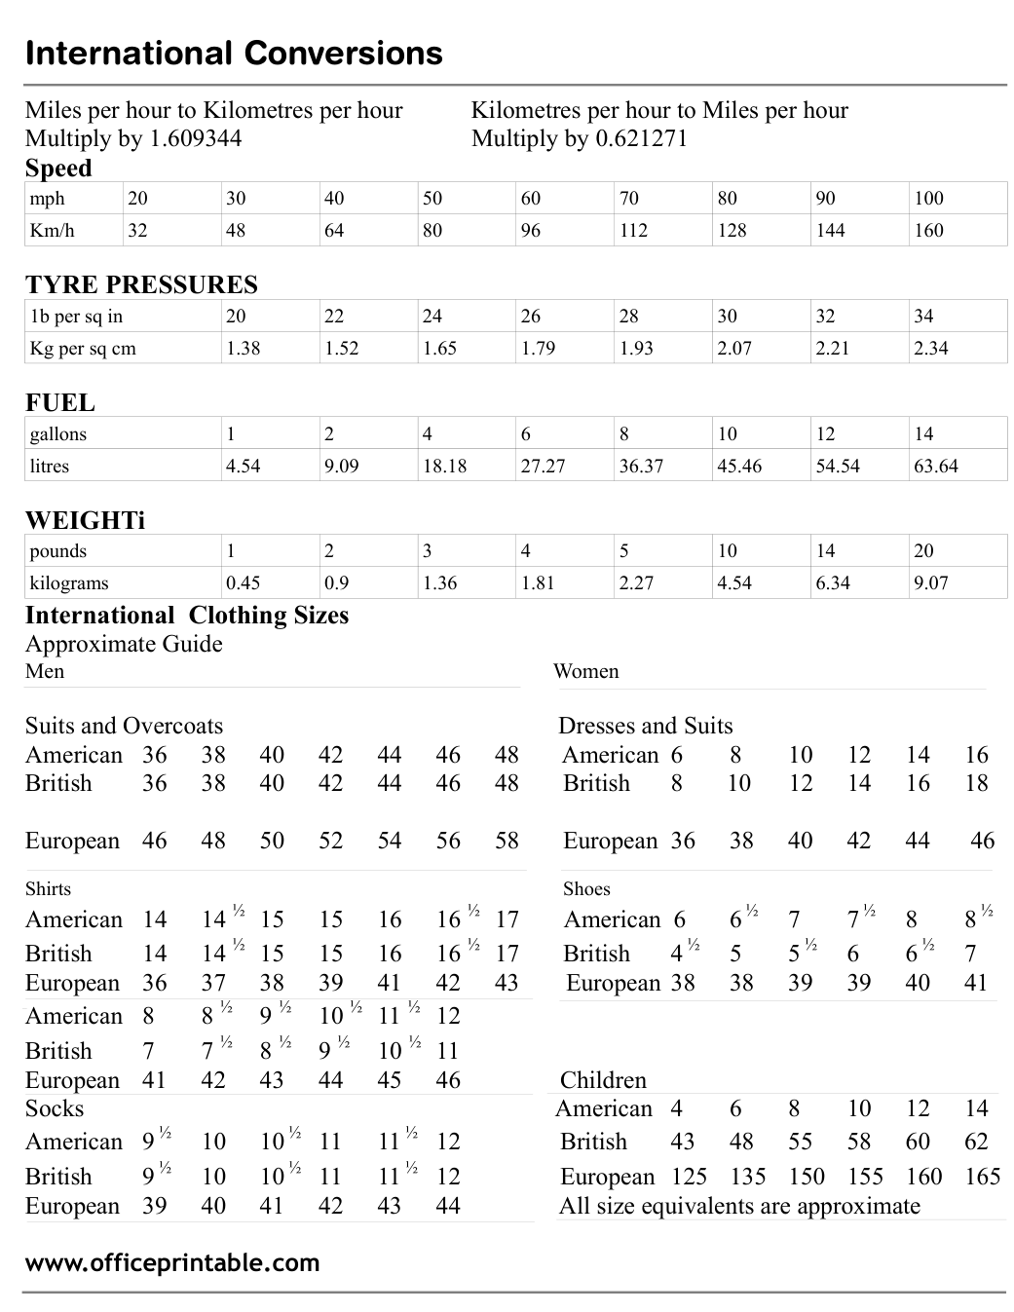

Free International Conversion Chart - Editable Content
The previous page preserves the printable layout. Use this editable section to customize labels, notes, rows, or field text before creating your own final version.
Original text / field | Custom text / notes
International Conversions
Miles per hour to Kilometres per hour Kilometres per hour to Miles per hour
Multiply by 1.609344 Multiply by 0.621271
Speed
mph
20
30
40
50
60
70
80
90
100
Km/h
32
48
64
96
112
128
144
160
TYRE PRESSURES
1b per sq in
22
24
26
28
34
Kg per sq cm
1.38
1.52
1.65
1.79
1.93
2.07
2.21
2.34
FUEL
gallons
1
2
4
6
8
10
12
14
litres
4.54
9.09
18.18
27.27
36.37
45.46
54.54
63.64
WEIGHTi
pounds
3
5
kilograms
0.45
0.9
1.36
1.81
2.27
6.34
9.07
International Clothing Sizes
Approximate Guide
Men Women
Suits and Overcoats Dresses and Suits
American 36
38
42
44
46
48 American 6
16
British 36
48 British
8 10 12
18
European 46
52
54
56
58 European 36
Shirts Shoes
American 14
14 ½ 15
15
16 ½ 17
American 6
6 ½
7
7 ½
8 ½
British
16 ½ 17 British
4 ½
5 ½
European
36
37
39
41
43
European 38
American 8
9 ½
10 ½ 11 ½ 12
10 ½ 11
45
46 Children
Socks American 4
American 9 ½
11 ½ 12 British
55
58
62
11 ½ 12 European 125
135
150
155
165
44 All size equivalents are approximate
www.officeprintable.com
officeprintable.com

