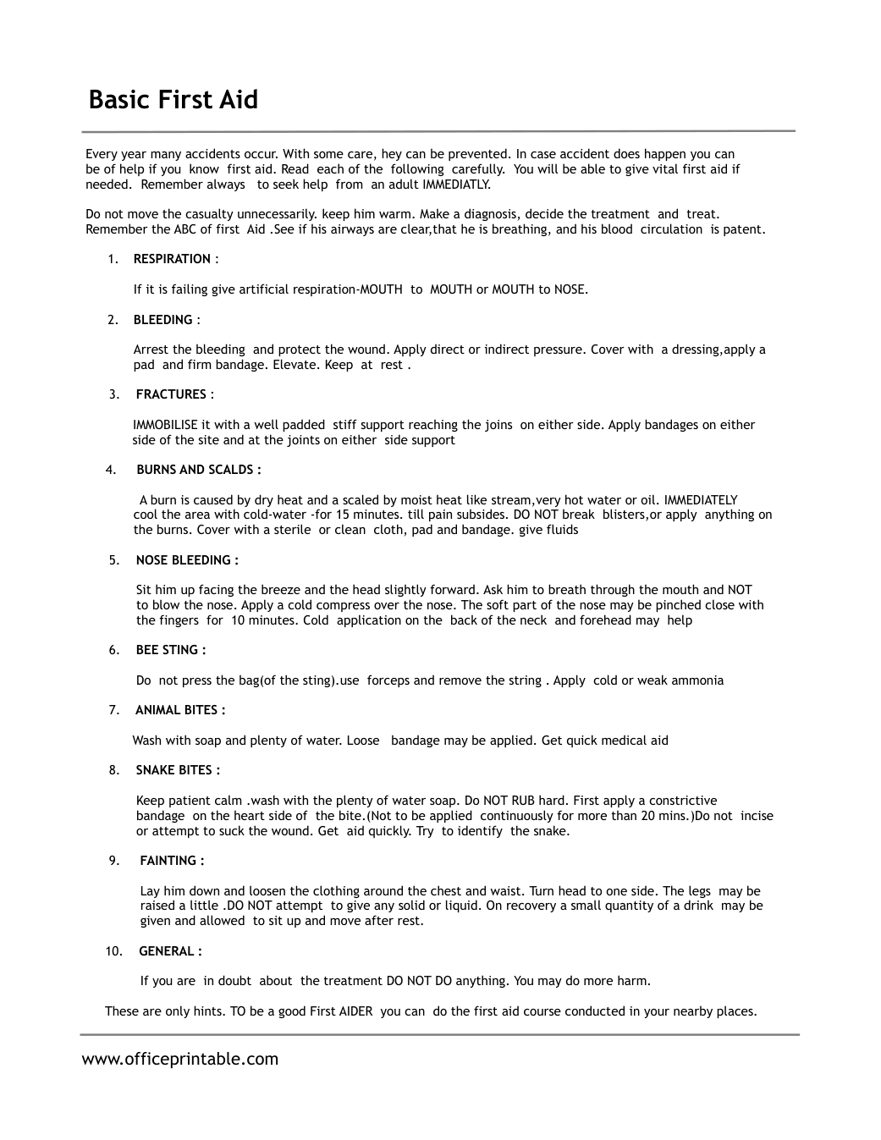

Free First Aid Quick Reference - Editable Content
The previous page preserves the printable layout. Use this editable section to customize labels, notes, rows, or field text before creating your own final version.
Original text / field | Custom text / notes
Basic First Aid
Every year many accidents occur. With some care, hey can be prevented. In case accident does happen you can
be of help if you know first aid. Read each of the following carefully. You will be able to give vital first aid if
needed. Remember always to seek help from an adult IMMEDIATLY.
Do not move the casualty unnecessarily. keep him warm. Make a diagnosis, decide the treatment and treat.
Remember the ABC of first Aid .See if his airways are clear,that he is breathing, and his blood circulation is patent.
1.
RESPIRATION :
If it is failing give artificial respiration-MOUTH to MOUTH or MOUTH to NOSE.
2.
BLEEDING :
Arrest the bleeding and protect the wound. Apply direct or indirect pressure. Cover with a dressing,apply a
pad and firm bandage. Elevate. Keep at rest .
3. FRACTURES :
IMMOBILISE it with a well padded stiff support reaching the joins on either side. Apply bandages on either
side of the site and at the joints on either side support
4. BURNS AND SCALDS :
A burn is caused by dry heat and a scaled by moist heat like stream,very hot water or oil. IMMEDIATELY
cool the area with cold-water -for 15 minutes. till pain subsides. DO NOT break blisters,or apply anything on
the burns. Cover with a sterile or clean cloth, pad and bandage. give fluids
5. NOSE BLEEDING :
Sit him up facing the breeze and the head slightly forward. Ask him to breath through the mouth and NOT
to blow the nose. Apply a cold compress over the nose. The soft part of the nose may be pinched close with
the fingers for 10 minutes. Cold application on the back of the neck and forehead may help
6. BEE STING :
Do not press the bag(of the sting).use forceps and remove the string . Apply cold or weak ammonia
7. ANIMAL BITES :
Wash with soap and plenty of water. Loose bandage may be applied. Get quick medical aid
8. SNAKE BITES :
Keep patient calm .wash with the plenty of water soap. Do NOT RUB hard. First apply a constrictive
bandage on the heart side of the bite.(Not to be applied continuously for more than 20 mins.)Do not incise
or attempt to suck the wound. Get aid quickly. Try to identify the snake.
9. FAINTING :
Lay him down and loosen the clothing around the chest and waist. Turn head to one side. The legs may be
raised a little .DO NOT attempt to give any solid or liquid. On recovery a small quantity of a drink may be
given and allowed to sit up and move after rest.
10. GENERAL :
If you are in doubt about the treatment DO NOT DO anything. You may do more harm.
These are only hints. TO be a good First AIDER you can do the first aid course conducted in your nearby places.
www.officeprintable.com
officeprintable.com

