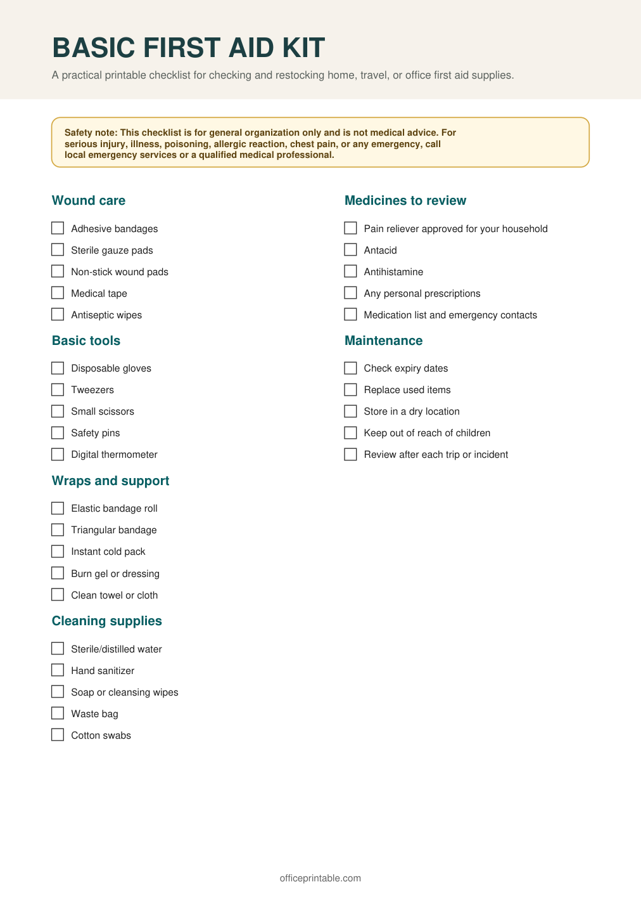

Free First Aid Kit Checklist - Editable Content
The previous page preserves the printable layout. Use this editable section to customize labels, notes, rows, or field text before creating your own final version.
Original text / field | Custom text / notes
BASIC FIRST AID KIT
A practical printable checklist for checking and restocking home, travel, or office first aid supplies.
Safety note: This checklist is for general organization only and is not medical advice. For
serious injury, illness, poisoning, allergic reaction, chest pain, or any emergency, call
local emergency services or a qualified medical professional.
Wound care
Medicines to review
Adhesive bandages
Pain reliever approved for your household
Sterile gauze pads
Antacid
Non-stick wound pads
Antihistamine
Medical tape
Any personal prescriptions
Antiseptic wipes
Medication list and emergency contacts
Basic tools
Maintenance
Disposable gloves
Check expiry dates
Tweezers
Replace used items
Small scissors
Store in a dry location
Safety pins
Keep out of reach of children
Digital thermometer
Review after each trip or incident
Wraps and support
Elastic bandage roll
Triangular bandage
Instant cold pack
Burn gel or dressing
Clean towel or cloth
Cleaning supplies
Sterile/distilled water
Hand sanitizer
Soap or cleansing wipes
Waste bag
Cotton swabs
officeprintable.com

