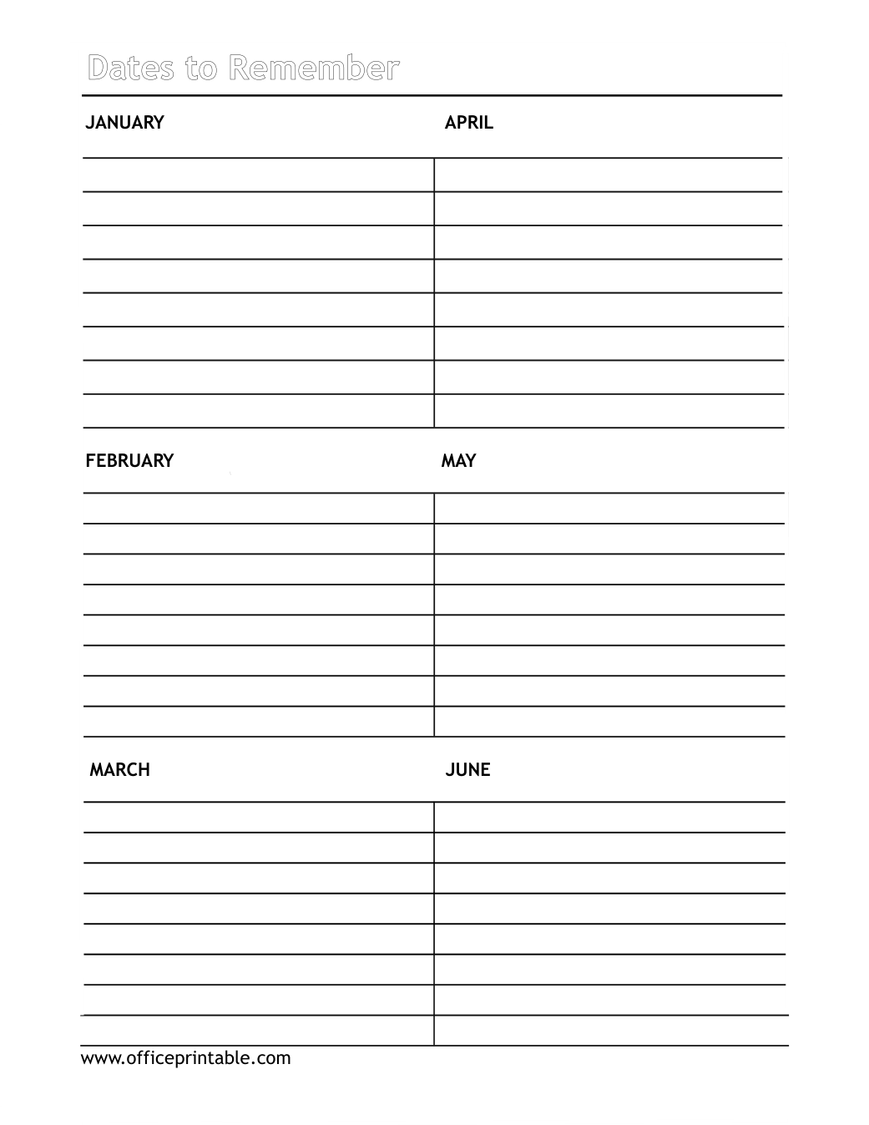

Free Dates to Remember: Jan-Jun - Editable Content
The previous page preserves the printable layout. Use this editable section to customize labels, notes, rows, or field text before creating your own final version.
Original text / field | Custom text / notes
Dates to Remember
JANUARY APRIL
FEBRUARY MAY
MARCH JUNE
www.officeprintable.com
officeprintable.com

