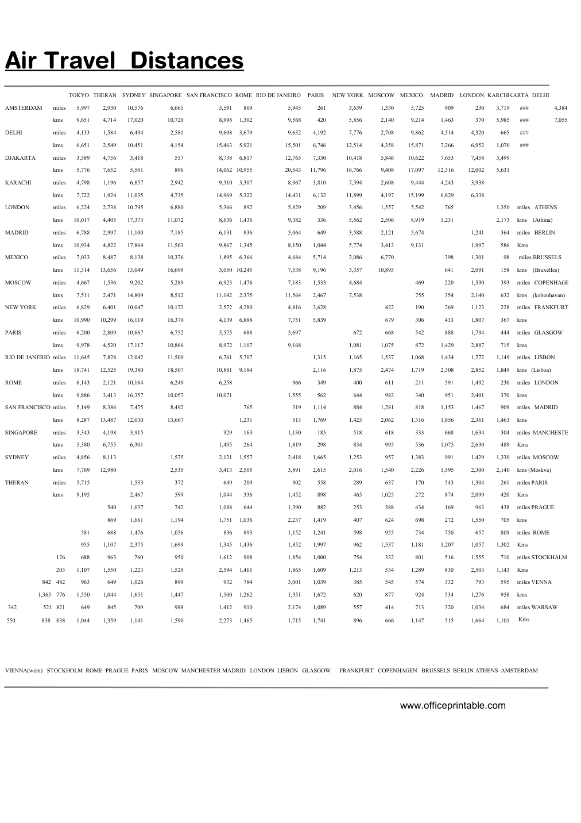

Free Air Travel Distances Chart - Editable Content
The previous page preserves the printable layout. Use this editable section to customize labels, notes, rows, or field text before creating your own final version.
Original text / field | Custom text / notes
Air Travel Distances
TOKYO THERAN
SYDNEY SINGAPORE
SAN FRANCISCO ROME RIO DE JANEIRO
PARIS
NEW YORK
MOSCOW
MEXICO
MADRID
LONDON KARCHIKARTA DELHI
AMSTERDAM
miles
5,997
2,930
10,576
6,661
5,591
809
5,945
261
3,639
1,330
5,725
909
230
3,719
###
4,384
kms
9,651
4,714
17,020
10,720
8,998
1,302
9,568
420
5,856
2,140
9,214
1,463
370
5,985
7,055
DELHI
4,133
1,584
6,494
2,581
9,608
3,679
9,632
4,192
7,776
2,708
9,862
4,514
4,320
665
6,651
2,549
10,451
4,154
15,463
5,921
15,501
6,746
12,514
4,358
15,871
7,266
6,952
1,070
DJAKARTA
3,589
4,756
3,418
557
8,738
6,817
12,765
7,330
10,418
5,846
10,622
7,653
7,458
3,499
5,776
7,652
5,501
896
14,062 10,955
20,543
11,796
16,766
9,408
17,097
12,316
12,002
5,631
KARACHI
4,798
1,196
6,857
2,942
9,310
3,307
8,967
3,810
7,394
2,608
9,444
4,243
3,938
7,722
1,924
11,035
4,735
14,969
5,322
14,431
6,132
11,899
4,197
15,199
6,829
6,338
LONDON
6,224
2,738
10,795
6,880
5,366
892
5,829
209
3,456
1,557
5,542
765
1,350
miles ATHENS
kms (Athina)
10,017
4,405
17,373
11,072
8,636
1,436
9,382
336
5,562
2,506
8,919
1,231
2,173
6,788
2,997
11,100
7,185
6,131
836
5,064
649
3,588
2,121
5,674
1,241
364
miles BERLIN
10,934
4,822
17,864
11,563
9,867
1,345
8,150
1,044
5,774
3,413
9,131
1,997
586
7,033
8,487
8,138
10,376
1,895
6,366
4,684
5,714
2,086
6,770
398
1,301
98
miles BRUSSELS
kms (Bruxelles)
11,314
13,656
13,049
16,699
3,050 10,245
7,538
9,196
3,357
10,895
641
2,091
158
4,667
1,536
9,202
5,289
6,923
1,476
7,183
1,533
469
220
393
miles COPENHAGE
kms (kobenhavan)
7,511
2,471
14,809
8,512
11,142
2,375
11,564
2,467
755
354
632
6,401
10,047
10,172
2,572
4,280
4,816
3,628
422
190
269
1,123
228
miles FRANKFURT
10,990
10,299
16,119
16,370
4,139
6,888
7,751
5,839
679
306
433
1,807
367
6,200
2,809
10,667
6,752
5,575
688
5,697
672
668
542
888
1,794
444
miles GLASGOW
9,978
4,520
17,117
10,866
8,972
1,107
9,168
1,081
1,075
872
1,429
2,887
715
RIO DE JANERIO miles
11,645
7,828
12,042
11,500
6,761
5,707
1,315
1,165
1,537
1,068
1,434
officeprintable.com

